Together We Can: Wealth creation and community development
Leicestershire Cares https://www.leicestershirecares.co.uk/ is a local charity and membership organisation that seeks to connect business with the local community, so nobody is left behind. I have been working for Cares for three years and many of our “simple” truths are ever more relevant to the divided world we increasingly find ourselves in.
At the heart of what we do is a belief that community is important, and wealth can be measured by more than just balance sheets and profits. It is in everyone’s interest to work together to create communities where people flourish and live rewarding, fulfilling lives. The business sector often has a wealth of resources, skills and experience it can share within the local community. The key being that each side seeks to understand and work in partnership with the other for mutual benefit.
The rise of corporate social responsibility and shared vision within the business community places a greater emphasis on businesses seeking to give back and be active participants in the local community. For many businesses this commitment to giving back is now part of their “mission”, reflected in their corporate values and a key driver for recruiting and retaining staff.
However, reality is often not that simple. The rise of globalisation means that many significant decisions, for example the way local industry might develop, are taken in foreign countries with little opportunity for local control. The perennial debate of should business pay staff more or pay more taxes rather than decide how to support communities continues. On the community side debates rage about which communities are represented, who decides what is funded. The reduction of funding to the sector means groups can end up competing rather than cooperating.
How you frame and answer the questions these issues raise is in part influenced by your political persuasion. Modern politics evolves around questions such as; what is the role of the state and markets, how do we respond to globalisation and climate change, how do we ensure accountability and ultimately what constitutes a “good life”?
A wealth creation approach to community development moves beyond “income” as the sole measure of a “good life”. Income is important, but “crucially” for people living in a poor community, income can be “stop start” and leave them very vulnerable to economic downturns. A community that offers security, a sense of belonging, affordable housing, decent schools, health provision and infrastructure has a “communal wealth” that provides a solid foundation for the community to thrive and be resilient through the highs and lows of economic activity.
Communities that provide these are more likely to thrive, attract new investment and produce educated people who want to succeed and remain within their communities. A wealth creation approach is a “win win” for community and business and one that must be developed and explored.
A wealth creation approach encourages joined up thinking and challenges people to ask how an activity adds value to a community. The Ford foundation emphasises the importance of value chains to this approach:
“A value chain is a business model in which independent producers, buyers and other players in the chain (e.g. aggregators, processors, inspectors, policy-makers, trainers, suppliers, consumers) work together to create value and share risk and reward. Value chain participants intentionally consider how to create economic, social and environmental benefits. Such a focus forms the basis for positive reciprocal relationships among participants. A value chain connects the demand and supply sides of a market in such a way that all parties in the chain benefit”.
Economic planning and community development converge. Local authorities encourage dialogue and “wealth creation” is shared. This approach varies from deciding to invest in and promote certain types of economic growth which benefit “poor” communities to relatively simple measures such as: a local factory with a canteen purchasing locally produced food or a local authority building into its contracting procedures a “social value” dimension, so that contracts are awarded to firms who give back.
This quickly moves beyond giving cuddly toys to sick children at Christmas, to a much more systematic approach where, for example, apprenticeships and training are offered, and there is a commitment to wherever possible including local firms and suppliers in supply chains.
In addition, many firms have a diverse range of skills and resources that can be utilised for community good. This can vary from letting community groups use meeting rooms, to coaching and mentoring community leaders. Likewise, many community groups have a detailed knowledge of local communities and can advise the business community on how best different community groups might work with their business.
This approach is powerful because it facilitates dialogue and understanding. The more companies integrate into their local community, the more they will support its growth and development. Likewise, the more community leaders see business as motivated by more than economic profit, the more likely they are to trust and work with them. Through working together each side understands the issues and pressures the other faces.
The sustainable global development goals are an attempt at a global level to harness “joined up” thinking so nobody is left behind. Many businesses are actively seeking to develop how they can harmonize three core elements: economic growth, social inclusion and environmental protection to ensure sustainable development. The seventeen SDG’s are universal, indivisible and transformative. They acknowledge that inequality between people within states as well as between states has a huge impact on the wellbeing. Hence the mantra, “nobody left behind” 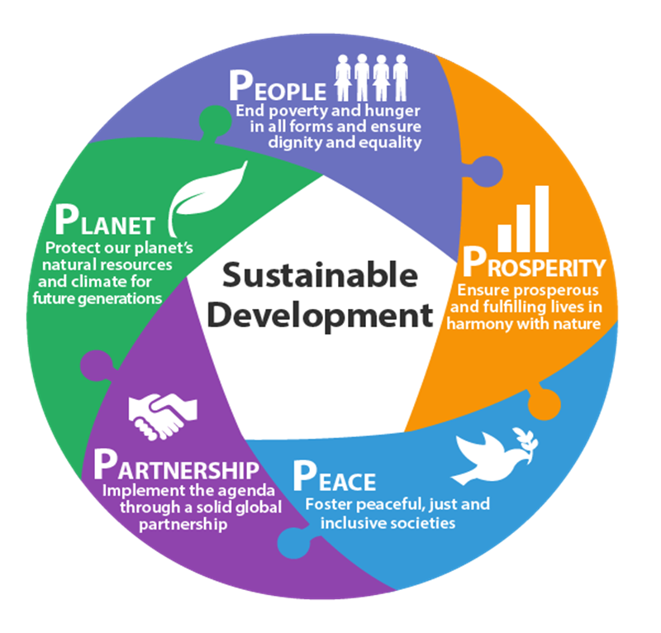

The Five P’s in the diagram above provide a solid SDG framework which local partnerships of community, government and business stakeholders can use to develop local action plans to create a “wealthy community”.
Such partnerships may find stakeholders coming at these issues from different perspectives, disagreeing and perhaps even questioning the motivation of others. However, I firmly believe that once people start working together, trust and understanding builds, which enable common agendas to be developed. Combine that with a common interest in improving the “place” where you live and work then you have a powerful platform for change where much can be achieved and a truly “wealthy” community will emerge and thrive.
#TogetherWeCan

Kieran Breen
CEO Leicestershire Cares

